**System Sequence Diagram:** Manually turn lights on and off via Amazon Dash Button

**Main Success Scenario:**

1. The user enters a room equipped with an Amazon Dash button and a controllable light source.
2. The User presses the Amazon Dash button
3. The light source is now on if it was off prior to pressing the Amazon Dash button or is now off if it was on prior to pressing the Amazon Dash button

**Alternate flows:**

3A. The controllable light source fails to switch states

1. The User or Administrator removes old light source from server list and re-adds it.

3C. Amazon Dash Button is not connected to the local wifi network

1. The user uses the Amazon app to connect the Amazon Dash button to the local wifi network

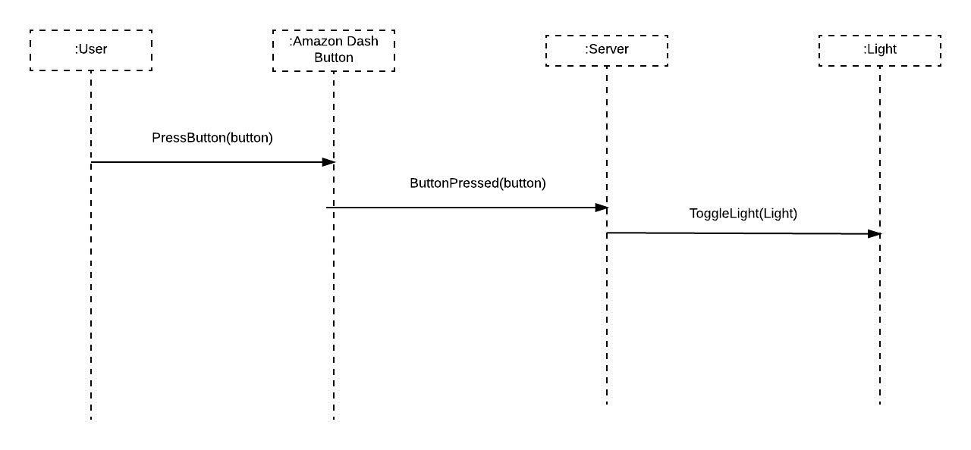

**System Sequence Diagram:** Turn on lights by entering a room

**Main Success Scenario:**

1. The user walks into a room that has no connected light source currently on.
2. The mobile app sends a message to the server telling it what room it has entered.
3. The server recieves the information and determines which light sources are in the room and need to be turned on.
4. The server turns on all connected lights available in the room.

**Alternate flows:**

1A. Light source is manually turned on through app before entering room

1. Server determines that light source was manually turned on by Amazon Dash button override
2. No changes are made to light source status

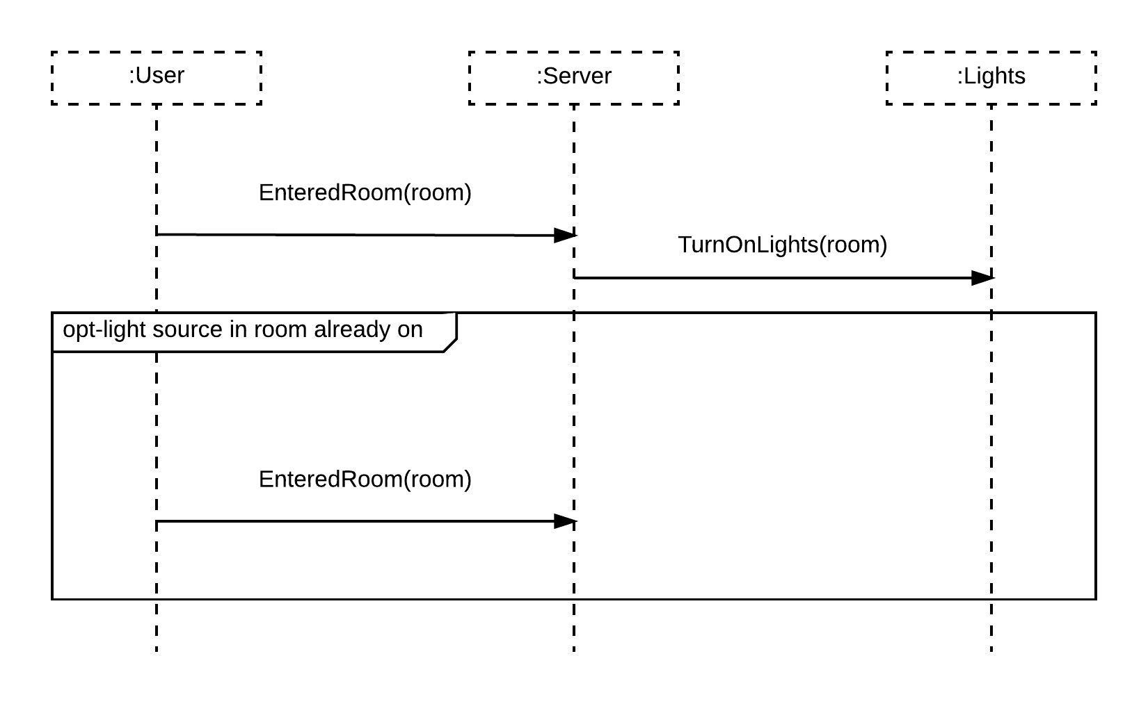

**System Sequence Diagram:** Turn off speaker by leaving a room

**Main Success Scenario:**

1. The User is in a room with a speaker that is currently playing music
2. The User leaves the current room
3. The mobile app connects to a speaker in the new room that is closer to the User than the previous speaker
4. Speaker in previous room stops playing music

**Alternate flows:**

4A. If the new room the User has entered contains no speaker

1. The app continues stays connected to the last speaker or the closest speaker

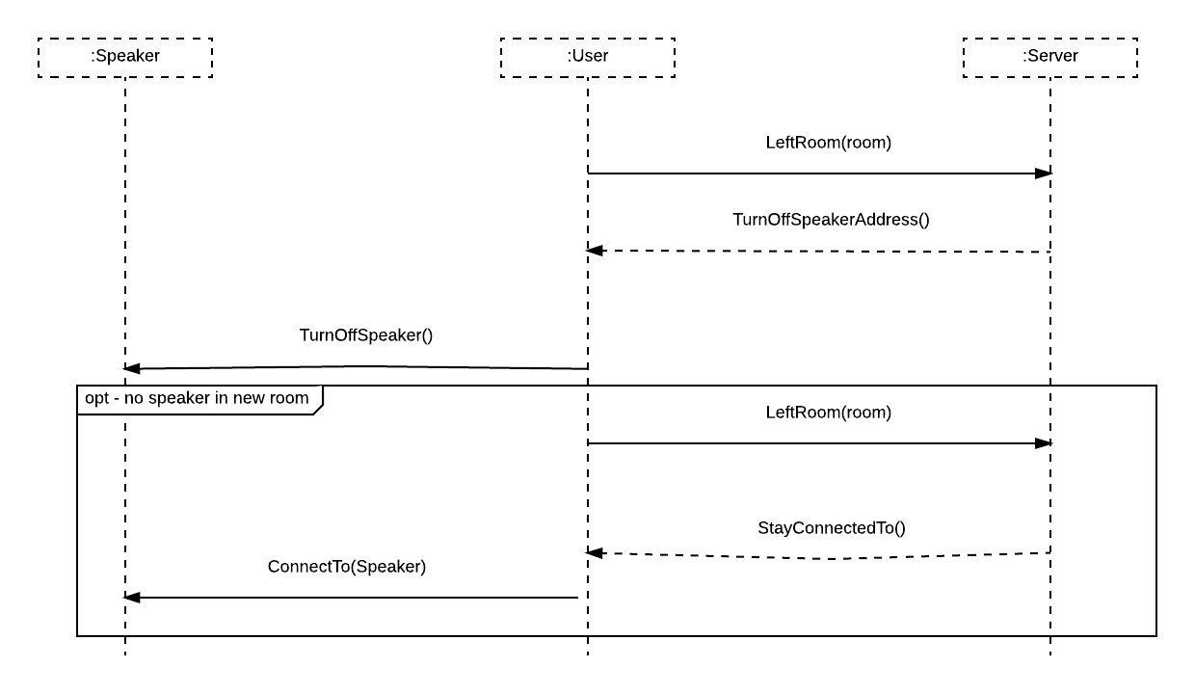

**System Sequence Diagram:** Control brightness of lights via app

**Main Success Scenario:**

1. User has app open
2. User goes to the light intensity setting in the app
3. User manipulates light intensity setting
4. App determines which room User is in
5. All lights in the room the User is in are off if the setting is at zero or off on and have a brightness proportional to the setting.

2A. Specific light source is not listed on app

1. Administrator adds light source and room to server list

4A. Brightness does not change when intensity setting is manipulated

1. User checks that light is capable of adjusting brightness
2. Administrator removes and re-adds light source to list.

